**Day 2, Part 6, 13:30 - 14:30 (1 hr)**

**Individual computer assignment followed by group discussion**

**Exploring heterogeneity:   
conduct subgroup analysis and interpret the results related to the case study**

We will practice with the fiber supplementation study data that we also discussed in the previous assignment. We will use Review Manager (RevMan) 5.3 to conduct the random-effects meta-analysis and subgroup analyses.

Below you see several characteristics. The Excel dataset **fiberdata_for RevMan.xlsx** is also provided.

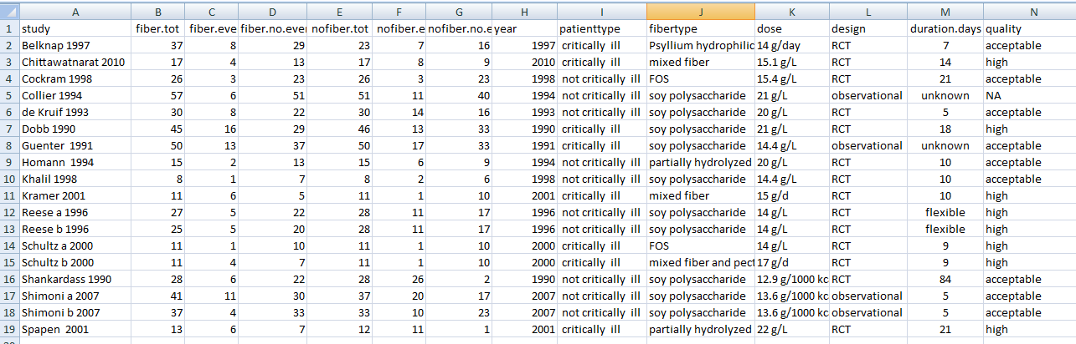

Some of the data have been transported to Revman 5.3, in the file   
**fiber and prebiotic supplementation in enteral nutrition subgroups.rm5**.

1. First, Open RevMan by double clicking on the fiber.....rm5 file.
2. A first step in RevMan is always to make sure that all your studies are available.  
   The left pane in RevMan is very important. In the left pane, click on “Studies and references”, to check whether all 18 studies are included. Presence of an identifier per study is sufficient, like “Belknap 1997”, no literature reference data are needed in this assignment.

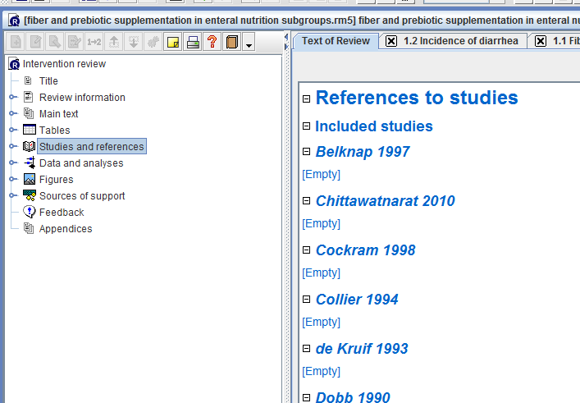

1. The second step in RevMan, before you can conduct a meta-analysis, is to add the comparison that you are interested in, i.e. the treatment groups that you want to compare. Which is the comparison that you are interested ?

In this case, that is the comparison between fiber and fiber-free EN treatment groups, i.e. Fiber supplementation.

1. You can check whether this comparison is already in the RevMan file (otherwise you could add it to the RevMan file).   
   Check this by double-clicking in the left pane on “Data and analyses”. Is the comparison present?

Yes, Fiber supplementation.

1. The third step in RevMan is to add the outcome that you are interested in.   
   In this example we are interested in the risk of diarrhoea. Do you think this is a binary (dichotomous) outcome or a continuous outcome (on patient level)?

We know how many patients suffered from diarrhoea, and how many did not suffer from this. On patient level, this means that a patient does or does not suffer from diarrhoea, which makes it a binary outcome.

1. We already provided the outcome to the RevMan file. Double click on “Fiber supplementation” to check this. What do you see?   
     
   You see two outcomes: Incidence of diahrroea overall, and per subgroup.
2. Each outcome corresponds to a meta-analysis. First we will work with the “overall“ incidence of diarrhoea. Double click on “Incidence of diarrhoea overall” . What do you see?  
     
   You will see the results of a Mantel-Haenszel random-effects meta-analysis with all 18 studies, with as effect measure the Risk Ratio.
3. In the left pane, right-click with your mouse on “Incidence of diarrhoea overall” . Note that here you may add or delete studies, rename the outcome, add subgroups, etc.

In the right pane, you may switch the effect size measure (or outcome measure) from RR to odds ratio or risk difference. Press several times on the RR button and check what happens with the results.   
You can also press the “RE” button to switch between Random-effects and fixed-effect analyses.  
What happens with the difference between the two treatment groups? And what happened with the heterogeneity?

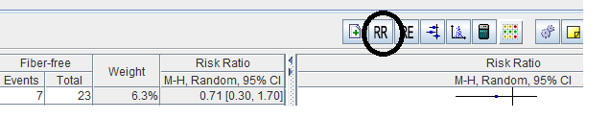

Depending on the effect size measure, the heterogeneity and the difference between the groups (RR, OR, or risk-difference) change. Also the statistical significance changes.

1. Check the second outcome of our comparison (incidence of diarrhoea per critically ill subgroup). This contains the subgroup analysis for the critically ill patients vs. the not-critically ill patients. Express in words what you see.  
     
   The forest plot shows whether the effect of fiber-supplementation differs between critically ill and not critically ill patients.
2. If you use a different effect size measure or a random- or fixed-effect approach, again the results will change.   
   Is the subgroup effect statistically significant for each effect size measure?

Yes, it is, but not with the same strength. The p-value varies between 0.01 and 0.04, and also the other characteristics of the subgroup test vary when different outcome measures are used.

**OPTIONAL – IF YOU HAVE TIME AND ARE INTERESTED:**

1. You may conduct yourself also a subgroup analysis for the old versus the newer studies, where old means: study was published before the year 2000. We will investigate whether the effect of fiber-supplementation has changed over the years.
   1. In the left pane, right-click on the comparison “Fiber supplementation”, and “add outcome”.
   2. Add a dichotomous outcome / press Next
   3. Name the outcome “Incidence of diarrhoea - studies before or after 2000” / Next
   4. Choose for MH random-effects analysis, with RR as effect size measure / Next / Next

First subgroup: old studies

* 1. Add a subgroup for the new outcome. Name the subgroup “Old studies” / Continue
  2. Select: Add study data to the new subgroup
  3. Use the filter to select studies till 1999. Highlight all studies until 1999 and press finish.

Next subgroup: new studies

* 1. Right click in the left pane on the outcome “Incidence of diarrhoea - studies before or after 2000” and add a subgroup “new studies”
  2. Add study data to the new subgroup
  3. Select studies using the filter from 2000 onwards. Highlight the studies and press finish.
  4. Copy the data from the excel file into RevMan. Do this by creating the same variable old / new studies, and sorting the data by this variable and study name. Now copy and paste the values into RevMan.
  5. Conduct the meta-analysis in RevMan.

